Session 2025-2026

Vision: To be a well-known centre for pursuing computer education through innovative pedagogy, value-based education and industry collaboration | Mission: To establish learning ambience for ushering in computer engineering professionals in core and multidisciplinary area by developing Problem-solving skills through emerging technologies.
Program Educational Objectives of the program (PEO): (broad statements that describe the professional and career accomplishments)
PEO1 | Preparation | P: Preparation | Pep-CL abbreviation pronounce as Pep-si-lL easy to recall
PEO2 | Core Competence | E: Environment (Learning Environment)
PEO3 | Breadth | P: Professionalism
PEO4 | Professionalism | C: Core Competence
PEO5 | Learning Environment | L: Breadth (Learning in diverse areas)

Program Outcomes (PO): (statements that describe what a student should be able to do and know by the end of a program)

Keywords of POs:
Engineering knowledge, Problem analysis, Design/development of solutions, Conduct Investigations of Complex Problems, Engineering Tool Usage, The Engineer and The World, Ethics, Individual and Collaborative Team work, Communication, Project Management and Finance, Life-Long Learning
PSO Keywords: Cutting edge technologies, Research

“I am an engineer, and I know how to apply engineering knowledge to investigate, analyse and design solutions to complex problems using tools for entire world following all ethics in a collaborative way with proper management skills throughout my life.” to contribute to the development of cutting-edge technologies and Research.

Integrity: I will adhere to the Laboratory Code of Conduct and ethics in its entirety.

Name and Signature of Student and Date
(Signature and Date in Handwritten)
Disha Angalwar
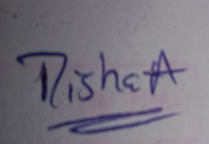

Session | 2025-26 (EVEN) |  | Course Name | JAVA FSD Lab
Semester | 4 |  | Course Code | 23ADS1407
Roll No | 4 |  | Name of Student | Disha Angalwar
Practical Number |  | 09
Course Outcome |  | - Understand the concept of file handling in java.  - Learn to perform file creation, writing, and reading.  - Apply Java I/O classes for data storage.
Aim |  | To connect a Java application to a MySQL database using JDBC and perform basic database operations (SELECT, INSERT,  UPDATE, DELETE).
Problem Definition |  | Develop a Java application that connects to a MySQL database using JDBC and allows the user to perform basic database  operations like inserting new records, updating existing records, retrieving data, and deleting records efficiently.
Theory  (100 words) |  | Java Database Connectivity (JDBC) is an API that allows Java programs to communicate with databases. It offers methods to create a connection, run SQL queries, and handle the results obtained. JDBC includes classes like Connection, Statement, PreparedStatement, and ResultSet. The Connection class is used to connect to the database, Statement is used to execute SQL commands, and ResultSet holds the data retrieved from queries. PreparedStatement supports parameterized queries, enhancing performance and reducing the risk of SQL injection. JDBC enables CRUD operations—Create, Read, Update, and Delete—making database management efficient. It is commonly used in enterprise-level applications for secure and scalable data operations.
Procedure and Execution  (100 Words) |  | Algorithm:  - Start MySQL Server.  - Create database testdb.  - Create table student(id, name).  - Insert initial records into the table.  - Add MySQL Connector/J JAR file to Java project.  - Load JDBC driver and establish connection.  - Create Statement / PreparedStatement object.

- Execute SQL queries:

  - SELECT → retrieve data
  - INSERT → add record
  - UPDATE → modify record
  - DELETE → remove record

- Process results using ResultSet.
- Close connection to release resources.
Code:
1. SELECT Operation
Connection con = DriverManager.getConnection( "jdbc:mysql://localhost:3306/testdb","root","root");
Statement stmt = con.createStatement();
ResultSet rs = stmt.executeQuery("SELECT * FROM student");

while(rs.next()){
System.out.println("ID: "+rs.getInt("id")+
", Name: "+rs.getString("name"));
}
con.close();

🔹 2. INSERT Operation
String query = "INSERT INTO student (id, name) VALUES (?,
?)";
PreparedStatement pst = con.prepareStatement(query);

pst.setInt(1, 3); pst.setString(2, "Ravi");

int rows = pst.executeUpdate(); System.out.println(rows + " record inserted.");

🔹 3. UPDATE Operation
String query = "UPDATE student SET name=? WHERE id=?"; PreparedStatement pst = con.prepareStatement(query);
pst.setString(1, "Amit"); pst.setInt(2, 3);

int rows = pst.executeUpdate(); System.out.println(rows + " record updated.");
🔹 4. DELETE Operation
String query = "DELETE FROM student WHERE id=?"; PreparedStatement pst = con.prepareStatement(query);

pst.setInt(1, 3);

int rows = pst.executeUpdate(); System.out.println(rows + " record deleted.");
Output:
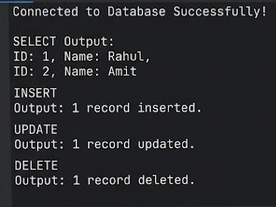

Output Analysis | The SELECT query effectively fetches data from the database, while the INSERT operation is used to successfully add new records. The UPDATE statement modifies existing data based on specified conditions, and the DELETE operation removes particular records as required. The use of PreparedStatement enhances security by preventing SQL injection attacks and also improves execution efficiency. Additionally, properly closing database connections is important as it prevents memory leaks and ensures optimal use of system resources, contributing to better performance and stability of the application.
Link of student Github profile where lab assignment has  been uploaded | https://github.com/dishaangalwar84/JavaFSD

Conclusion | The experiment illustrates the effective integration of Java with MySQL through JDBC. All CRUD operations were carried out successfully, demonstrating how Java programs can communicate with databases. The use of PreparedStatement improves both security and performance. Overall, this practical builds a solid base for creating database-oriented applications in Java..
Plag Report (Similarity index < 12%) | 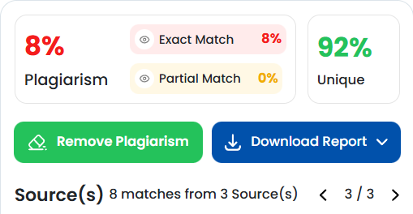
Date | 24 March 2026
Faculty signed observation page.

